

**Renewable Energy**

**AGU Town Hall Meeting Summary**

Figure Solar plant capturing the energy from the direct beam.

Figure Wind installations can provide large amounts of energy, but require accurate forecasts.

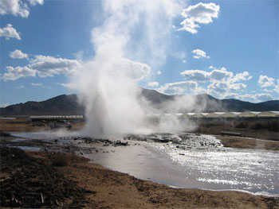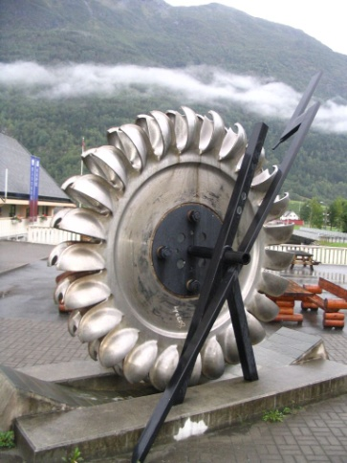At the AGU Annual Meeting 2009, a Town Hall was called to address the cross disciplinary research and environmental requirements necessary to support renewable energy in the coming years. Co-chaired by Betsy Weatherhead and Richard Eckman, NASA, the panelists and audience addressed the issues of most pressing concern for integration of renewable energy in the near future. Renewable energy is recognized as a growing part of today’s economy, is emerging as an important direction for society, and promises to be a component of any long-term climate change solution. All of the panelists highlighted the strong research needs for the both more developed renewable energy sources of wind and solar power, but also for the emerging energy sources, including biofuels, hydro-power and geothermal sources. Avi Gopstein made the strong case for applied research to allow efficient integration of renewable energy into the grid. Avi Gopstein further called for the need to take a system engineering approach to efficiently transition any new research to the practical level that will help integrate renewable energy into grid systems. The most critical needs to allow the integration are more accurate short-term forecasts and an understanding of climatological levels of renewable energy sources. Just Sharp, furthered the strong case for the economic importance of research to support renewable energy use, citing that currently estimated costs for wind renewable energy integration is between $270M and $1 billion USD today and that the primary driver in these costs are less than adequate forecasts. Climatological research is critical to the proper identification of new sites for renewable energy. The panelists pointed out that 1/10 m/s mis-estimation in wind results in $136M change in revenue as well as significant (2.6M tons) CO2 emissions because of having to use traditional fossil fuels.

Figure 3 Geothermal energy—successfully captured in some locations.

Figure A hydro-turbine prior to placement.

All four panelists, as well as members of the audience agreed that current resources were not commensurate with the economic and environmental importance of the problem. Further points that were unanimously agreed on were that the fundamental research and improvements in both short-term forecasts and climatological studies were best carried out by government funded efforts, while tailored forecasts and interpretation of data and studies were best handled by industry. Chet Koblinsky referenced a plan developed within NOAA to address the critical issues of improved forecasting and climatological studies for the weather driven renewable energies, but stressed that the work could not be achieved with existing resources.

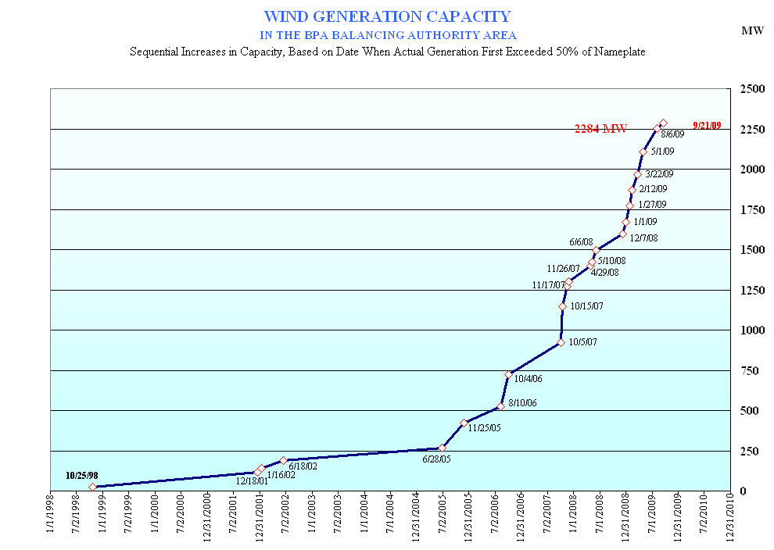

Unlike our current energy structure, which relies heavily on well understood technology powered by fossil fuels, renewable energy depends on new techniques and often a very limited understanding of the meteorological, solid Earth, and hydrological conditions. Key help assure successful development of renewable energy as a viable, long term energy source for society. The work required is formidable, however the research capabilities exist to address the problems outlined at this meeting. New resources will be needed to address the most pressing problems. The amount of funded required is considerably less than the economic benefits of investing appropriately in renewable energy systems. Briefly: the challenges are formidable, the issues are important and there are scientists ready to address these challenges.

Recent increases in renewable energy capabilities has increased the importance of accurate forecasts and a better understanding of climatological impacts.

**Panelists:** Justin Sharp, Iberdrola; Avi Gopstein, DOE; Lawrence Friedl, NASA; Chet Koblinski, NOAA

**Organizing Committee:** Mike McElroy, Harvard; John Snow, U. Oklahoma; Justin Sharp, Iberdrola; Bart McManus, Bonneville Power Administration; Len Pietrafesa, North Carolina State University.